A TECHNICAL REPORT ON STUDENTS’ INDUSTRIAL WORK EXPERIENCE SCHEME (SIWES)

AT

A.G VISION CONSTRUCTION COMPANY NIGERIAN LIMITED,
SIGRIE, SONG, ADAMAWA STATE

FROM: 7TH OCTOBER, 2024
TO: 7TH FEBRUARY, 2025

TITLE PAGE

BY
AHMED SALAHUDEEN
ET/CE/ND/23/010

THIS TECHNICAL REPORT IS SUBMITTED TO THE DEPARTMENT OF CIVIL ENGINEERING TECHNOLOGY IN PARTIAL FULFILLMENT OF THE REQUIREMENT FOR THE AWARD OF NATIONAL DIPLOMA (ND) IN CIVIL ENGINEERING TECHNOLOGY, FEDERAL POLYTECHNIC MUBI

DEDICATION
I dedicate this report to God Almighty, who saw me through the period of my SIWES training programme and also to my parents who always supported and believed in me I’m forever grateful.

ACKNOWLEDGEMENTS
I most firstly ventilate my profound gratitude to Almighty ALLAH for granting me the straight ,health, talent, and best of all for giving me the divine enablement and success to compile this SIWES report.
My best gratitude goes to my Mother for her monism, adulation, prayers, encouragement, motherly love and affection to me, my sincere gratitude goes to my esteemed father for his financial support, and my brothers and sisters for their direct and indirect support and motivation towards my studies.
My profound gratitude goes to my department lectures, My supervisor in person of Tgts. Auwal Idris and SIWES Coordinator in person of Engr. Sunu Jude for their full support and advice towards my studies and SIWES.

ABSTRACT
The student industrial work experiences scheme (SIWES) on the industrial training fund, (ITF) is been designed for all student undergoing the national diploma programme, I was exposed and participated in so many construction aspect during my training I was thought about introduction machines in construction company, their types and working principles, road construction, laying of sub-grade, sub-base and laying of asphalt.

Table of Contents
TITLE PAGE i
DEDICATION ii
ACKNOWLEDGEMENTS iii
ABSTRACT iv
Table of Contents v
CHAPTER ONE 1
1.0 INTRODUCTION 1
1.1 BRIEF HISTORY OF SIWES 1
1.2 AIM AND OBJECTIVES OF SIWES 2
1.3 BRIEF HISTORY OF A.G VISION CONSTRUCTION COMPANY NIGERIAN LIMITED 3
CHAPTER TWO 6
2.1 INTRODUCTION TO MACHINES IN A CONSTRUCTION COMPANY THEIR TYPE AND WORKING PRINCIPLES 6
2.1.2 PROCESS INVOLVE IN CRUSHER PLANT 7
2.3 LAYING OF SUBGRADE 8
2.4 SUBGRADE CONSTRUCTION PROCESS: 9
2.5 LAYING OF SUB-BASE LAYERS 10
CHAPTER THREE 11
3.1 SCARIFICATION OF EXISTING ASPHALT 11
3.2 SOME TECHNICAL WORDS 12
3.3 LABORATORY AND IN-SITU EXPERIMENTS 14
CHAPTER FOUR 15
4.0 PROBLEMS ENCOUNTERED 15
4.1 THE RELEVANCE OF STUDENT INDUSTRIAL WORK EXPERIENCE SCHEME (SIWES) PROGRAMME 15
CHAPTER FIVE 16
CONCLUSION AND RECOMMENDATIONS 16
5.1 CONCLUSION 16
5.2 RECOMMENDATIONS 17
REFERENCES 18

CHAPTER ONE

1.0 INTRODUCTION

1.1 BRIEF HISTORY OF SIWES
SIWES was founded in 1973 by ITF (Industrial Training Funds) to address the problem of tertiary institution graduates' lack of appropriate skills for employment in Nigerian industries. The Students' Industrial Work Experience Scheme (SIWES) was founded to be a skill training programme to help expose and prepare students of universities, Polytechnics and colleges of education for the industrial work situation to be met after graduation.
This system facilitates the transfer from the classroom to the workplace and aids in the application of knowledge. The program allows students to become acquainted with and exposed to the experience required in handling and operating equipment and machinery that are typically not available at their schools. `
Prior to the establishment of this scheme, there was a rising concern and trend among industrialists that graduates from higher education institutions lacked appropriate practical experience for employment. Students who entered Nigerian universities to study science and technology were not previously trained in the practical aspects of their chosen fields. As a result of their lack of work experience, they had difficulty finding work.
As a result, employers believed that theoretical education in higher education was unresponsive to the needs of labor employers. Thousands of Nigerians faced this difficulty till 1973. The fund's main motivation for establishing and designing the scheme in 1973/74 was launched against this context.
The ITF (Industrial Training Fund) organization decided to aid all interested Nigerian students and created the SIWES program. The federal government officially approved and presented it in 1974. During its early years, the scheme was entirely supported by the ITF, but as the financial commitment became too much for the fund, it withdrew in 1978. The National Universities Commission (NUC) and the National Board for Technical Education (NBTE) were given control of the scheme by the federal government in 1979. The federal government handed over supervision and implementation of the scheme to ITF in November 1984. It was taken over by the Industrial Training Fund (ITF) in July 1985, with the federal government bearing entire responsibility for funding.

1.2 AIM AND OBJECTIVES OF SIWES
The Industrial Training Fund’s Policy Document No. 1 of 1973 which established SIWES outlined the objectives of the scheme as:
- Provide an avenue for students in Institutions of higher learning to acquire industrial skills and experience in their respective courses of study.
- Prepare students for the Industrial Work situation they are likely to experience after graduation.
- Expose students to work methods and techniques of handling equipment and machinery that may not be available in their Institutions.
- Make the transition from school to the world of work easier; and enhance students’ networks for later job placements.
- Provide students with an opportunity to apply their knowledge to real work situations, thereby bridging the gap between theory and practice; and
- Enlist and strengthen Employers’ involvement in the entire educational process; thereby preparing the students for employment in Industry and Commerce.

1.3 BRIEF HISTORY OF A.G VISION CONSTRUCTION COMPANY NIGERIAN LIMITED
AG Vision Construction, part of Abou Ghazaleh Group, represents the ongoing legacy of the Abou Ghazaleh family in the construction industry. It is led today by the family’s third and fourth generations that have succeeded in upholding the company’s position at the forefront of cutting-edge performance at all levels of the real estate development business.
Founded in 1890 thanks to Daher Abou Ghazaleh’s vision, the company started as a local contracting business specialized in building traditional housing units and constructing aqueducts. Decades of hard work and solid craftsmanship put the Abou Ghazaleh name on top of a business empire that continues to look forward to attaining new heights.
As Fayed Abou Ghazaleh took up the reins, he was compelled by the same innovative thinking that was at the core of his father’s strategy in running the business. That’s when the company started importing cement to Lebanon; hence introducing a new range of construction materials and heavy-duty equipment to the market, in addition to pioneering a whole new concept in building and design that allowed for the emergence of high-rise towers and more complex state-of-the-art structures.
Today, Group CEO Tony Abou Ghazaleh, along with his sons Elie as Managing Director and Fadi as Executive Director, draws from his predecessors’ enduring sense of business in running a multi-faceted, dynamic construction company that has not only grown across new areas of the industry but also across several markets. And with over a century’s worth of local hands-on experience, the company continues to bring innovative, prime real estate projects in both the residential and the commercial segments, with the support of its administrative headquarters in Abuja. Moreover, the Abou Ghazaleh name has a well-established foothold in West-Central Africa, namely as a limited liability company [LLC] duly registered in Nigeria; indeed, the company is now a major player in public construction works and considered the best construction company there undertaking a number of infrastructural projects, including roads, bridges and building construction, under the Federal Government’s oversight and sponsorship.

What Makes Us Nigerian?
For over a decade now, we have undertaken Construction and Development operations across several regions in Nigeria, one of the world’s fastest-growing frontier economies, and Africa’s leading oil producer. The Nigerian market has presented us with a diversity of investment opportunities that have strengthened our sense of commitment and contribution.
Abou Ghazaleh Contracting Nigeria Ltd was incorporated in 2002, launching its first project in the central state of Kogi, the capital of which holds the confluence of Nigeria’s famous Niger and Benue rivers. 2006 marked our first major project in Kogi State, undertaking the full-fledged construction phases of two main city bridges.
AG Vision Construction Nigeria Ltd was incorporated in 2007; and its first major engineering project comprised the complete setup of a 40-km highway stretch, with 3 bridges built in Adamawa State. By 2008, AG Vision Construction Nigeria Ltd was operating in 8 different Nigerian states, namely Kogi, Adamawa, Cross River, Benue, Anambra, Abia, Imo, and Katsina. In 2009, our portfolio involved building a road network of 300 km spanning the entirety of the Nigerian territory, in addition to projects related to building construction, water dams, water purification stations, irrigation projects, and soil erosion control.

1.4 ORGANIZATION CHART OF A.G VISION CONSTRUCTION COMPANY NIGERIAN LIMITED.
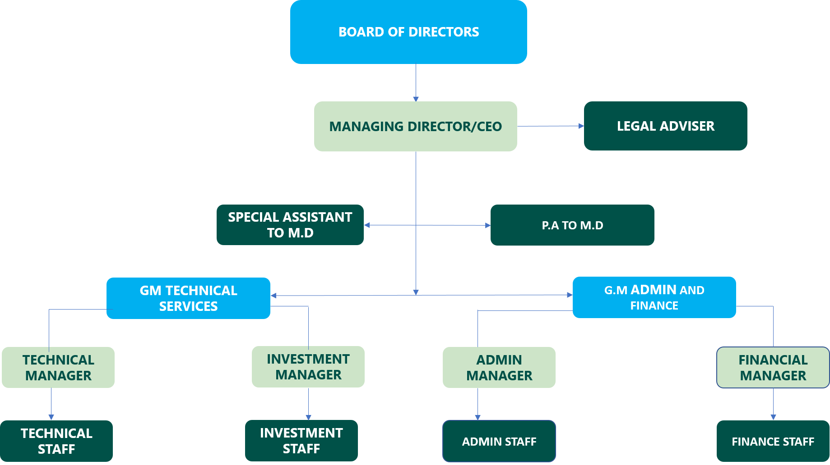

Figure 1: Organizational Chart

CHAPTER TWO

2.1 INTRODUCTION TO MACHINES IN A CONSTRUCTION COMPANY THEIR TYPE AND WORKING PRINCIPLES
Excavators: Used for excavating trenches, foundations, and clearing debris.
Bulldozers: Used for earthmoving task such as levelling terrain, pushing soil, and clearing obstacles.
Graders: Used for levelling and grading road surfaces to ensure smoothness and proper drainage.
Rollers: Used for compacting soil, asphalt, or concrete to create a solid and durable road surface.
Asphalt pavers: Used for laying asphalt evenly and efficiently to create road surfaces.
Crushing machine: is a typically large piece of equipment used to break down raw materials such as rocks, gravels, or minerals into smaller sizes.
Dump trucks: used for transportation and dumping of materials.
Water tankers: used for transportation and spraying of required water.
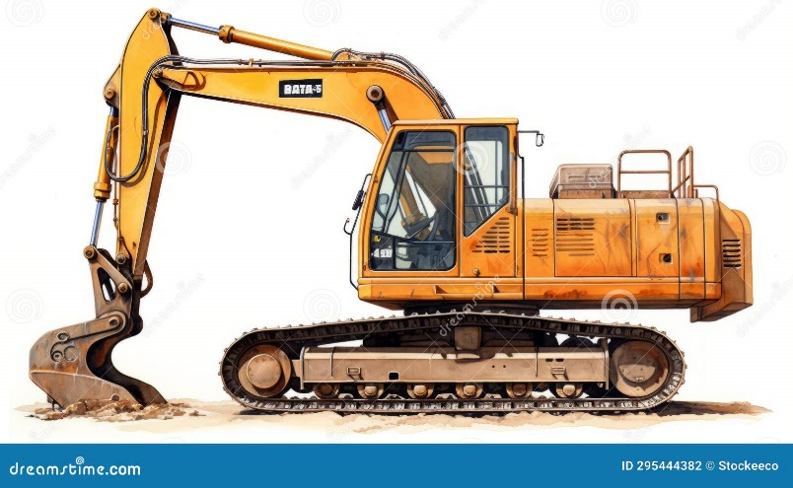
Mobile mixers: used for mixing, transporting and pouring of concrete. Etc.


Figure 2: Image of Excavator and Bulldozer

2.1.2 PROCESS INVOLVE IN CRUSHER PLANT
- Pit
- Feder bucket
- Jaw
- Primary conveyor
- Secondary conveyor
- Screen cone
- Return conveyor
Common sizes produced by crusher
Coarse aggregate 5mm-20mm
Fine aggregate 0.075-5mm
Dust below 0.075mm
Crushed stones used as a base material in road construction as drainage stone, or in production of concrete.
Gravels used in landscaping, drainage systems and as base material for road and driveways.

Some types of screen mesh in crusher
- 3/4 “
- 1/2 ‘’
- 3/8’’
- 1 ‘’
- Dust

2.2 ROAD CONSTRUCTION
Road construction is a laborious operation that might take several years to complete, depending on the length of the finalised roadway. It takes meticulous planning, many evaluations, and a variety of evaluations, including analyses of the environment and the structure, and it includes multiple construction teams and plant equipment. Once construction has started on a road, numerous steps must be completed before the road is ready for vehicle traffic.
Road construction is the establishment of an engineered, unbroken right-of-way or roadbed that overcomes geographical barriers and has levels low enough to allow for car or foot traffic, and is needed to follow legal or official norms.

2.3 LAYING OF SUBGRADE
The foundation of the pavement structure is known as subgrade. Preparation of subgrade consists of all operations before the pavement structure is placed over it and compacted. The subgrade may be situated on an embankment, by excavation, or at the existing ground surface. In all the above cases, Site Clearance Clearing Grubbing Operation should be done before starting the pavement structure
The laying of subgrade it is usually 15cm thick
construction. After that, the grading operation is started as per the design and drawing of the highway plan and profile. Subgrade performance depends on two corresponding factors, which are as follows.
- Load bearing capacity: Compaction, moisture content, and soil type usually affect subgrade load bearing capacity.
- Volume changes: When exposed to excessive moisture or freezing conditions, most soils undergo volume changes, affecting subgrade performance.
The following sets of equipment are necessary for the planned progress of road subgrade construction work.
- Excavator
- Air Compressor & Pavement Breaker /Jack Hammer
- Tippers /Dumpers
- Motor Graders
- Vibratory Compactor
- Tractors Dozer with Disc Harrows/Spreading Blade/Ploughs
- Water Bowser with Sprinklers etc.

2.4 SUBGRADE CONSTRUCTION PROCESS:
- The subgrade in road construction shall be prepared as per the MORTH specifications if it is not mentioned in the construction contract technical specifications.
- The limits of filling shall be marked by fixing batter pegs at regular intervals on both sides of the layer, and the working line should be marked with lime powder.
- The layer should be built 30cm wider than the designed and drawing dimensions so that after proper compaction is achieved up to the toe, the surplus materials shall be trimmed to get the properly compacted slopes of the subgrade.
- Where the fill is to be deposited against an existing subgrade, continuous horizontal benches of 30cm wide shall be cut into the old slope.
- In the cutting section, where cutting is to be done up to the subgrade top, its top layer shall be loosened and re-compacted as per technical specification.
- The topsoil in the borrow area shall be removed by grubbing or stripping so that earth without vegetation is excavated and loaded for the subgrade layer.
- Soil from approved borrow areas shall be excavated with Excavators and loaded onto tippers or dumpers for transportation to the stretch ready to receive fill Material.
- The material shall be dumped between the limiting lines marked with lime powder.
- The material shall be spread in layers of a uniform thickness not exceeding 250mm of compacted thickness. A grader or a combination of dozer and grader can be used for this activity.

2.5 LAYING OF SUB-BASE LAYERS
This is the layer of aggregate material laid on the subgrade, on which the base course layer is located. It may be omitted when there will be only foot traffic on the thickness of sub-base not less than 150mm, upto300mm pavement, but it is necessary for surfaces used by vehicles. many roads, drives, pavements and parking areas require an underground base that will spread the load of the surface paving material and also provides adequate drainage.
Granular material is laid over the soil or subsoil and compacted to create the right conditions for putting down such surface materials as paving blocks, asphalt or concrete.
This lower layer called the sub-base layer and a properly laid foundation will prevent subsidence, aid drainage, increase load bearing capacity, be sustainable and protect against wear and tear.

CHAPTER THREE

3.1 SCARIFICATION OF EXISTING ASPHALT
Pavement construction involves laying and compacting the various pavement layers. Asphalt pavement is typically laid using paving machines (paver), while concrete pavement may be poured and finished by hand or with specialized equipment.
- Subgrade Preparation: The subgrade is the natural soil beneath the road's surface. It must be properly prepared to provide a stable foundation for the road. This may involve adding or removing material, compacting the soil, and ensuring proper drainage.
- Pavement Layers: The pavement structure is built in layers, each serving a specific purpose:
a. Sub-base course (150-300mm): The sub-base layer is composed of aggregate materials like crushed stone or gravel. It provides additional support and drainage for the pavement.
b. Base Course (150-300mm): The base course sits on top of the subase and is typically made of more durable materials like crushed rock or asphalt. It provides further support and helps distribute the load evenly.
c. Binder Course (50-70mm):
An intermediate layer between the base course and the surface course. It adds structural strength and durability to the road.
d. Surface Course(25-50mm): The surface course, also known as the wearing course, is the top layer of the pavement. It is made of asphalt or concrete and provides a smooth, durable driving surface.
Pavement Construction: Pavement construction involves laying and compacting the various pavement layers. Asphalt pavement is typically laid using paving machines, while concrete pavement may be poured and finished by hand or with specialized equipment.
Road Dimensions
Width of wearing course =7.3m (both right- and left-hand sides)
Width of shoulder =5.5m (both sides)
Total width from shoulder to shoulder =12.8m
Depth of wearing course before rolling =50mm
Depth of wearing course after rolling =40mm

3.2 SOME TECHNICAL WORDS
Scarification (ripping): process of removing layers of existing pavement to prepare for resurfacing.
Regulation: refers to the process of applying water, mixing, levelling and compacting of laterite (earth work) on site.
Chipping: Also known as surface dressing refers to the process of spraying bitumen (S125) on the shoulder side covering with gravel.
Hauling: Process of transporting materials to the site.
Chainage: Distance with respect to the starting point.
Borrow pit: A place where material (laterite) is obtained.
Priming: process of spraying bitumen (MC1) etc.
Key learnings encompassed efficient teamwork, adherence to safety protocols, and mastering various construction techniques. Successfully contributed to the progress of Yola-Mubi Road maintenance.
Appendices
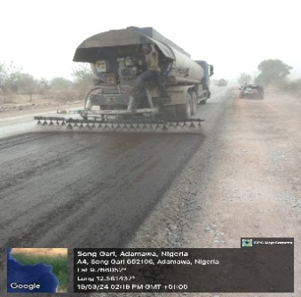
Figure 3: Tar boiler
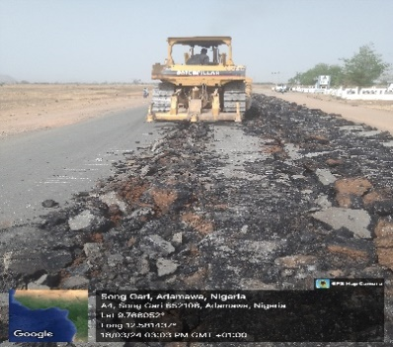
Figure 4: Bulldozer

3.3 LABORATORY AND IN-SITU EXPERIMENTS
- Sieve analysis
- Atterberg limit
- Compaction
- California bearing ratio (CBR)
- Bitumen extraction
- Bitumen penetration test
- bitumen tray test (MC1/S125)
- In-situ density test (sand replacement method)
- Asphalt delivering, laying and rolling temperature test
- Slump cone test (in-situ)
- Compressive strength of concrete test

CHAPTER FOUR

4.0 PROBLEMS ENCOUNTERED
The problem encounter during student industrial work experience SIWES include the;
- Accommodation is not arranged for the student on attachment to ease problems of rent and transportation fee.
- Few organizations rejects student for the attachment when requesting the form.

4.1 THE RELEVANCE OF STUDENT INDUSTRIAL WORK EXPERIENCE SCHEME (SIWES) PROGRAMME
The relevance of industrial training for the period of month program has been of great importance to me as follows.
- SIWES program provides me the opportunity to work in one or more areas of industry and this enable me to relate the theoretical knowledge to the practical work situation, which is a realistic way of determining the relevance of theory to practice.
- It provide me with an opportunity to apply knowledge in real work situation by bridging the gap between the theory and practical.
- It expose me to work method and techniques in handling equipment and operating it, which may not be available in the collage

CHAPTER FIVE

CONCLUSION AND RECOMMENDATIONS

5.1 CONCLUSION
During the period of four (4) month of student industrial work experience scheme (SIWES) it was concluded at A.G VISION CONSTRUCTION NIGERIAN LIMITED
The experience and determination carried out in these months has been achieved as regard to theoretical exposure. The work has been of great interest to me, practically handling equipment.
However, the aim is achieving reliable and standard field experiment became extremely relevant to me, my training cranes and castles limited, aids me to acquire good interesting farm ethics, use of tools and equipment and all quality practical working knowledge acquired in the class thereby bridging it’s gap with practical’s.
Finally, during my industrial attachment at A.G VISION CONSTRUCTION COMPANY NIGERIAN LIMITED
I was able to perform different experiment by myself and I also appreciate the knowledge that was impacted on me. The aim and objectives of ITF and SIWES has been achieved successfully.

5.2 RECOMMENDATIONS
I will like to plead the department of civil engineering to add more of industrial materials, and also teach the student how to use some of the materials before going out for student industrial work experience scheme (SIWES).
I am pleading to the department to at least pay three to four visit to the student undergoing the SIWES program in their respective industries, this to encourage the student to be constantly punctual and hard work during the cost of the industrial attachment. And I also want to plead ITF coordinator the should try to visit the establishment where student are undergoing there SIWES and likewise the sponsorship of the whole student on industrial attachment. I strongly, believed that the above mention points of recommendation should be considered.

REFERENCES
Britannica. (2013). Asphalt Bitumen published by Britannica Encyclopædia Retrieved 27 February, 2025 from https://www.britannica.com/science/bitumen
Daniel J. F. (2008). Planning, Design, and Operations. published by WC Aaron Publishers, New Jersey.
Daniel, R. (2011). Road construction theory, published by McGraw-Hill Ed
Dodge, R. W. (2010). Construction Site Preparation. Published by McGraw-Hill Ed

